Student’s name | …………………………………………………….…… | Grade | 4
Subject | Computer | Week No. | 12
Lesson Title | Operators | Unit
Worksheet No. ( 12 ) (Answer)

Question A: Write the correct name of each part.

Turn | Repeat | Event | Switch
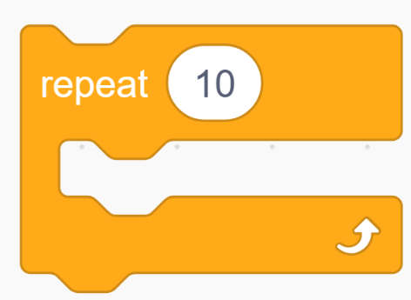



Event
Switch
Repeat
Turn
Good Luck

